**Co-workify**

* **What is Co-working Space:**

 Coworking is the situation in which several workers from different companies share an office space, allowing cost savings and convenience through the use of common infrastructure, such as equipment, utilities, and receptionist and custodial services.

* **About Co-workify app:**

In This app are divided into Three Categories

1. **Seller:**

Seller who has Add their workspace:

1. **Buyer:**

Buyer sees all workspace which available on Website. Also, he or she purchases any workspace according to their need.

1. Office_desk
2. Front_office
3. Conference room
4. **Admin:**

Admin is responsible for allowing to purchase any space.

(In this project we are using Django admin Panel as an admin.)

* How to Run App:
  + Create Virtual Environment
  + Then install **requirement.txt.**
  + After in terminal execute below command:
    - **python manage.py run server** (to run app)
* **Images of Buyer Login:**

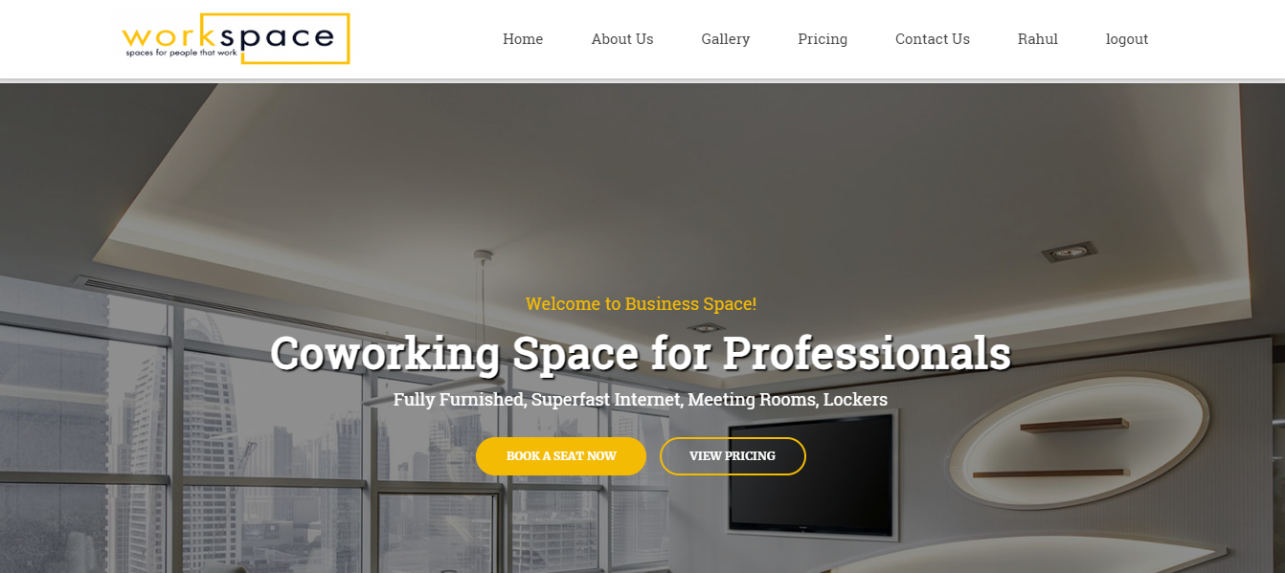

* Buyer login price Tab:

When click Apply to any Space Open Buyer Agreement for confirmation for buying space.

* **Buyer Confirmation Page:**

Once you confirm and agree our application send mail Both Parties (Buyer and Seller) for rental space confirm.

* After Admin confirm and give approvement for buyer to buy space.

* When Receive Approvement from Admin buyer Eligible for next (Payment Process).

* Payment Process:

* When payment is done buyer profile page Status is allocated.

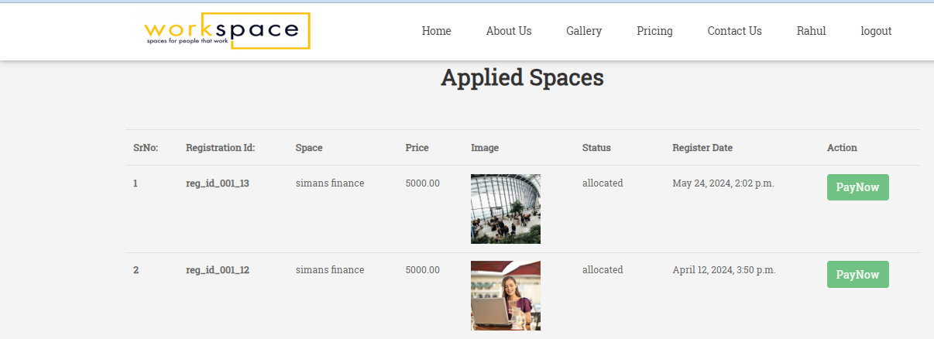

* **Images of Seller login**
* After login as a seller, he can add a new workspace.

* click Add workspace fill new workspace form.

* Add workspace More details (like images)

